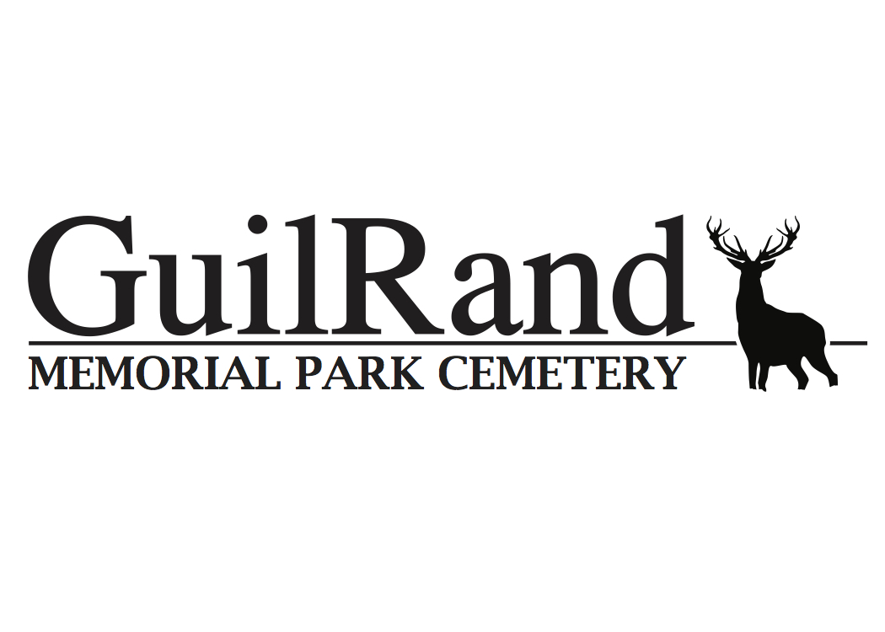
General Price List
1550 NC Highway 62 W, High Point, North Carolina 27263
(336) 355-1037

Grave Space Plots, Columbarium Niches and Memorial Bench:
- Grave Space: $995
- Premier Cremation Niche, Top 3 rows: $2,000
- Basic Cremation Niche, Bottom 3 rows: $1,500
- Cremation Memorial Bench: $2,500 includes 4 interments, 4 perpetual care, 1 open/close and 1 engraving.
  - Additional $500 per extra open/close, also $300 for extra engravings
- Memorial Bench: $1500
- Outer Burial Containers $1500
Fees:
- Opening/Closing: $1100 (Also Mausoleum Burial) (Oversized Vaults Extra $300 Fee)
- Opening / Closing: $500 (Niches, Benches and Cremation Burials)
- Perpetual Care: 10% and/or $100 whichever is greater (mandated by the state of NC and due at the time of grave space or niche purchase)
- Engraving Fee $300 (Mausoleum $600)
- Bench Rights: $500
- 2nd Interment Rights (Plot or Cremation Niche) $450
Memorials/Headstones:
- Single Headstone: $850 (vase with marker $150) (Also includes one engraving)
- Double Headstone: $1,700 (vase with marker $150) (Also includes one engraving)
- Temporary Granite Marker $250 (customer gets to keep after removed from cemetery)
Additional Fees for upgrades:
- Color change on headstone: $500
- Headstone Picture, black & white and/or color: $500
- Additional Vase: $200
- Death date inscription: $200
(Additional fees may be added based on any additional personalization or changes not listed above)
Outside Headstone Vendor Fees: All documentation must be received and approved by cemetery 1 week prior to installation. Guil-Rand does not take any responsibility for outside vender product and/or workmanship.
- Location Fee: $200 per grave space
- Install Fee: $300 per single headstone
- Install Fee: $500 per double headstone
ALL paperwork must be emailed to info@guilrand.com and approved per Cemetery Rules & Regulations before installation.
Documentation fee on all contracts: $300
Cabin Rental: $300

WE OFFER PROMOTIONAL PACKAGES FROM TIME TO TIME AND THEY ARE SUBJECT TO CHANGE WITHOUT NOTICE!

